Assignment # 2 12/3/2012

**Name = NC – Saad Masood**

**Course = BESE – 16A**

**Submit to : Lt. Col. Saleem**

# Chapter 5

# SECTION 5-1 Resistors in Series

**4. Determine the nominal resistance between pins 2 and 3 in the circuit board in Figure 5-68.**

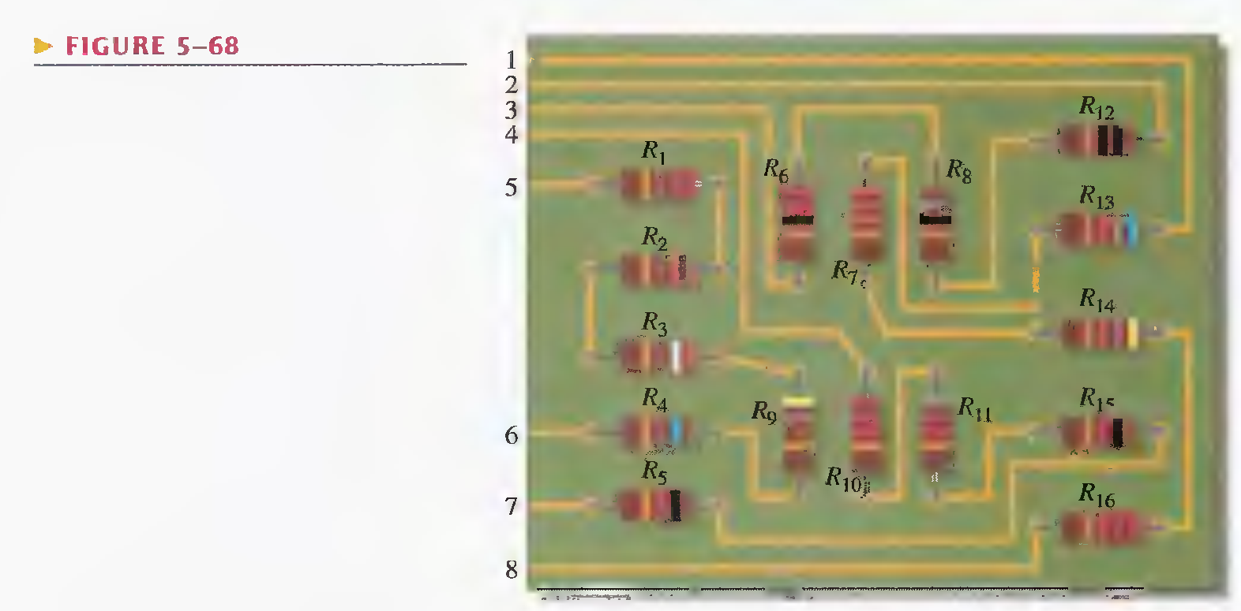

Ans: nominal resistance between pins 2 and 3 in the circuit board is

R12, R8, R6

**5. On the double-sided PC board in Figure 5-69, identify each group of series resistors. Note that many of the interconnections feed through the board from the top side to the bottom side.**

Ans: R1, R7 , R8 , and R10 are in series.

R2, R4 , R6 , and R11 are in series.

R3 , R5 , R9 , and R12 are in series.

# SECTION 5-1 Current in a Series Circuit

**9. Using 1.5 V batteries, a switch, and three lamps, devise a circuit to apply 4.5 V across either one lamp, two lamps in series, or three lamps in series with a single-control switch Draw the schematic.**

Ans:

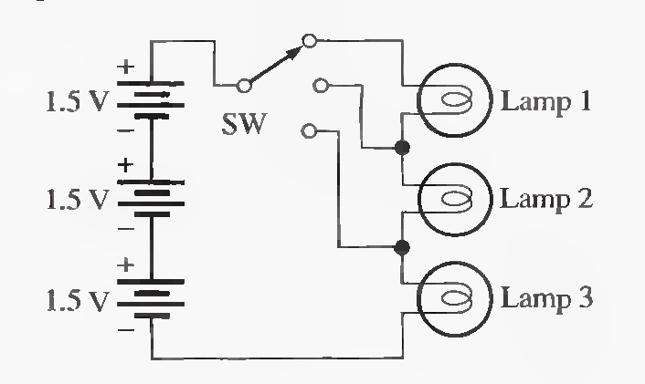

# SECTION 5-3 Total Series Resistance

**17. Find the total resistance in Figure 5-71 if all three circuits are connected in series.**

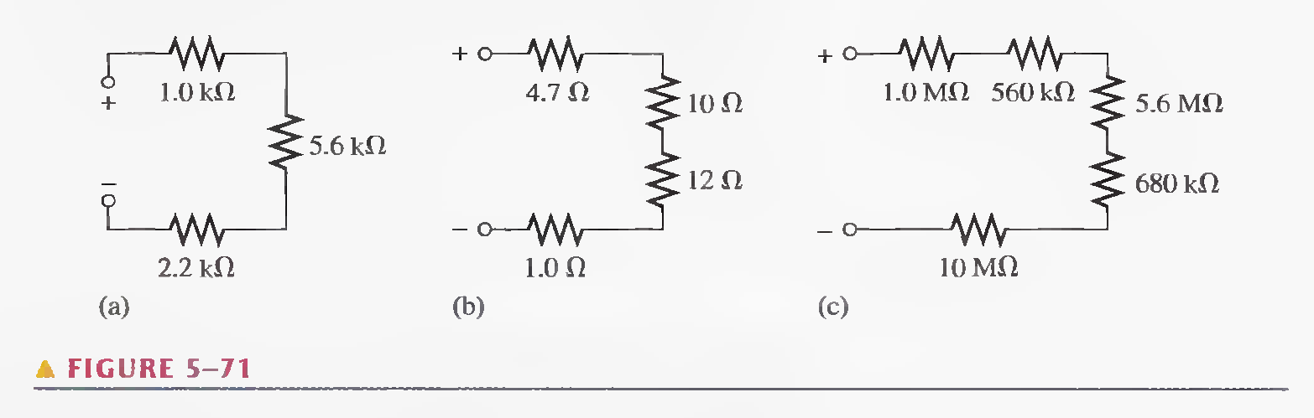

Ans: RT = 1000 + 560 + 5600 + 680 + 10000 = 17.840 MΩ

**18. What is the total resistance from A to B for each switch position in Figure 5-73?**

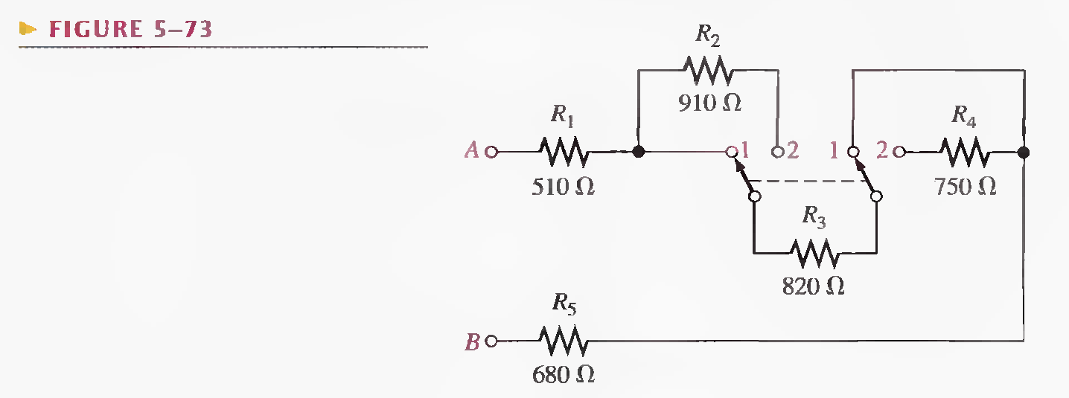

Ans: when both the switches are at position 2

RT = 510 + 910 + 820 + 750 + 680 = 3670 Ω

when both the switches are at position 2

RT = 510 + 820 + 680 = 2010 Ω

# SECTION 5-4- Application of Ohm's Law

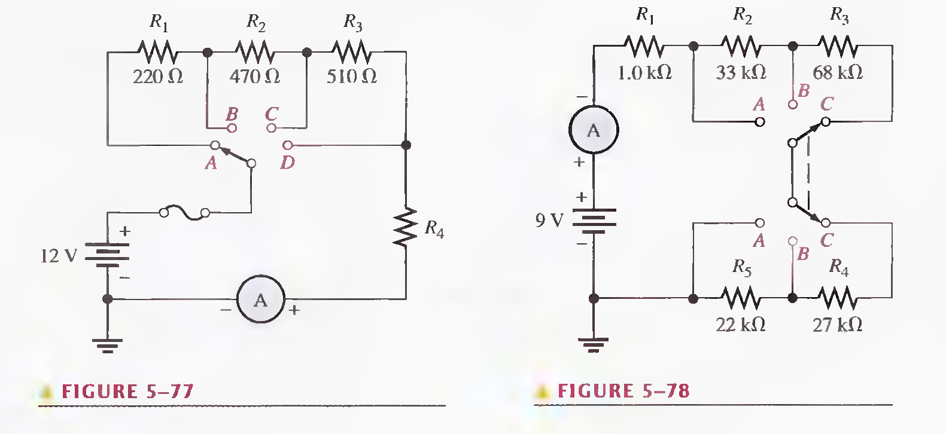

**25. For the circuit in Figure 5-77 the meter reads 7.84 mA when the switch is in position A**

1. **What is the resistance of R4 ?**
2. **What should be the meter reading for switch positions B, C, and D?**
3. **Will a 1/4 A fuse blow in any position of the switch?**

Ans: a) R123 = 220 + 470 + 510 = 1200 Ω

V = IR123 = (0.00784)(1200) = 9.4 V

Now drop across R4 is, V4 = 12 – 9.4 = 2.6 V

R4 = V/I = 2.6/(0.00784) = 331.6 Ω

b) for position B, RT = 470 + 510 + 331.6 = 1311.6 Ω

now I = V/RT  = 12/1311.6 = 9.1 mA

for position C, RT = 510 + 331.6 = 841.6 Ω

now I = V/RT  = 12/841.6 = 14.3 mA

for position D, RT = 331.6

now I = V/RT  = 12/331.6 = 36.2 mA

1. No

# SECTION 5-5 Voltage Sources in Series

**28. The term series opposing means that sources are in series with opposite polarities. If a 12 V and a 3 V battery are series opposing, what is the total voltage?**

Ans: VT = 12 + 3 = 15 V or -15 V

**29. Determine the total source voltage in each circuit of Figure 5-79.**

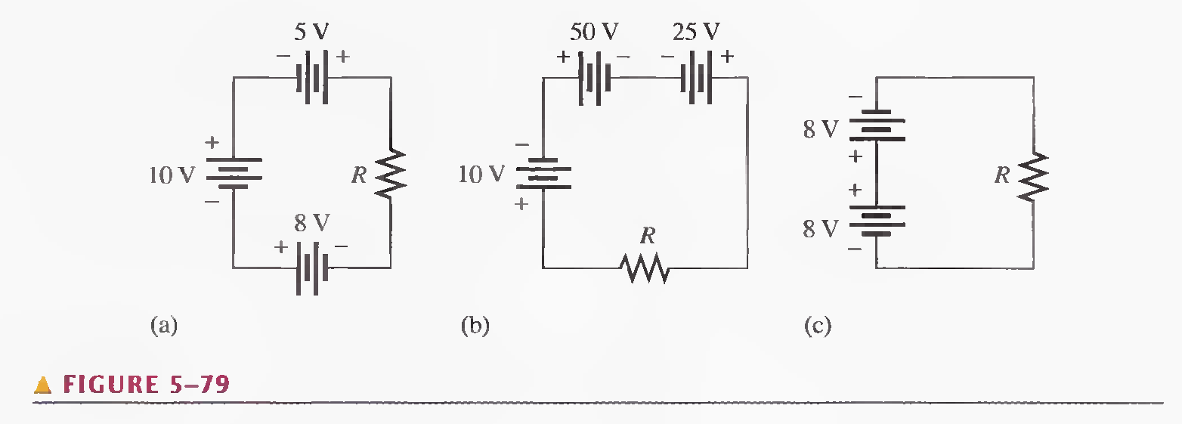

Ans: a) VT = 10 + 5 + 8 = 23 V

b) VT = 10 + 50 – 25 = 35 V

c) VT = 8 – 8 = 0 V

# SECTION 5-6 Kirchhoff's Voltage Law

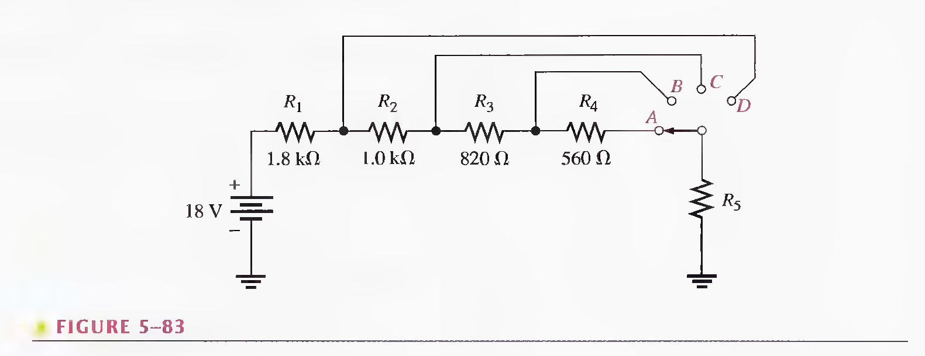

**35. Determine the voltage across R5 for each position of the switch in Figure 5-83. The current in each position is as follows: A, 3.35 mA; B, 3.73 mA; C, 4.50 mA; D, 6.00 mA.**

Ans: position A, voltage across R1 is, V1 = IR1 = (0.00335)(1800) = 6.03 V

Voltage across R2 is, V2 = IR2 = (0.00335)(1000) = 3.35 V

Voltage across R3 is, V3 = IR3 = (0.00335)(820) = 2.747 V

Voltage across R4 is, V4 = IR4 = (0.00335)(560) = 1.876 V

Now, Voltage across R5 is, V5 = 18 – (6.03 + 3.35 + 2.747 + 1.876) = 3.9970 V

Position B, voltage across R1 is, V1 = IR1 = (0.00373)(1800) = 6.714 V

Voltage across R2 is, V2 = IR2 = (0.00373)(1000) = 3.73 V

Voltage across R3 is, V3 = IR3 = (0.00373)(820) = 3.0586 V

Now, Voltage across R5 is, V5 = 18 – (6.714 + 3.73 + 3.0586) = 4.4974 V

Position C, voltage across R1 is, V1 = IR1 = (0.0045)(1800) = 8.1 V

Voltage across R2 is, V2 = IR2 = (0.0045)(1000) = 4.5 V

Now, Voltage across R5 is, V5 = 18 – (8.1 + 4.5) = 5.4 V

Position D, voltage across R1 is, V1 = IR1 = (0.006)(1800) = 10.8 V

Now, Voltage across R5 is, V5 = 18 – 10.8 = 7.2 V

**36. Using the result of Problem 35, determine the voltage across each resistor in Figure 5-83 for each switch position.**

Ans: see question 35

# SECTION 5-7 Voltage Dividers

**\*45. Design a variable voltage divider to provide an output voltage adjustable from a minimum of 10 V to a maximum of 100 V within ± 1 % using a 1 to 120 V source. The maximum voltage must occur at the maximum resistance setting of the potentiometer, and the minimum voltage must occur at the minimum resistance (zero) setting. The current is to be 10 mA.**

Ans:

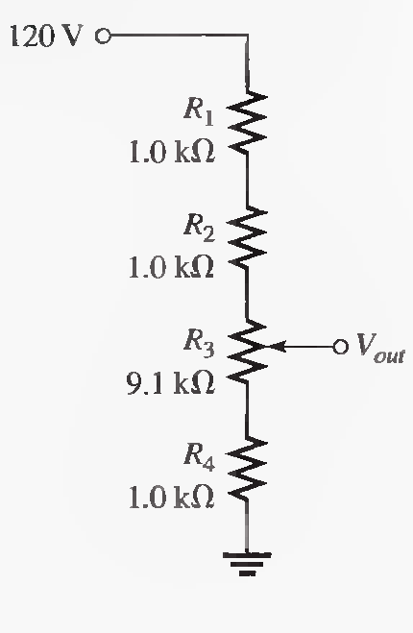

# SECTION 5-8 Power in Series Circuits

**50. A certain series circuit consists of a 1/8 W resistor, a 1/4 W resistor and a 1/2 W resistor. The total resistance is 2400 Ω. If each of the resistors is operating in the circuit at its maximum power dissipation, determine the following:**

**(a) I (b) V T (c) The value of each resistor**

Ans: a) PT = 1/8 + 1/4 + 1/2 = 7/8

P = I2 R 🡺 I2 = P/R = (7/8)/2400 = 19.09 mA

b) PT = IVT  🡺 VT = PT/I = (7/8)/19.09 = 45.83 V

c) P1 = I2 R1 🡺 R1 = P1/I2 = (1/8)/(0.01909)2 = 343.003 Ω

P2 = I2 R2 🡺 R2 = P2/I2 = (1/4)/(0.01909)2 = 686 Ω

P3 = I2 R3 🡺 R3 = P3/I2 = (1/2)/(0.01909)2 = 1.4 kΩ

**SECTION 5-9 Voltage Measurements**

**52. In Figure 5-91, how would you determine the voltage across R2 by measuring, without connecting a meter directly across the resistor?**

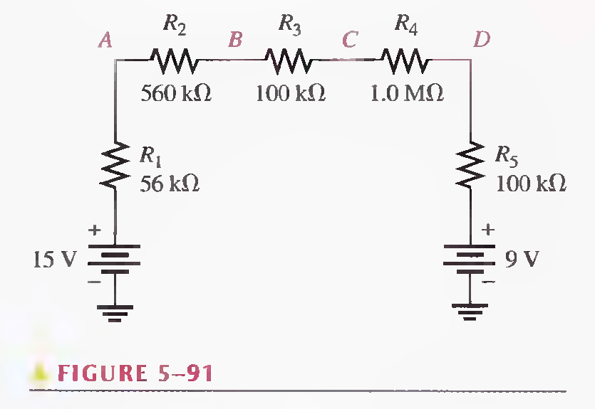

Solution: as R1, R2, R3, R4 and R5 in series. Find the equivalent resistance is

Re = R1 + R2 + R3 + R4 + R5 = 56+560+100+1000+100 = 1816 kΩ

And equivalent voltage is Ve = 15 - 9 = 6 V

Now current is I = V/R = 6/1816000 = 3.3 µA

And voltage across R2 is V2 = IR2 = (3.3e-6)(560e3) = 1.85 V

# SECTION 6-1 Resistors in Parallel

**1. Show how to connect the resistors in Figure 6-65(a) in parallel across the battery.**

Ans:

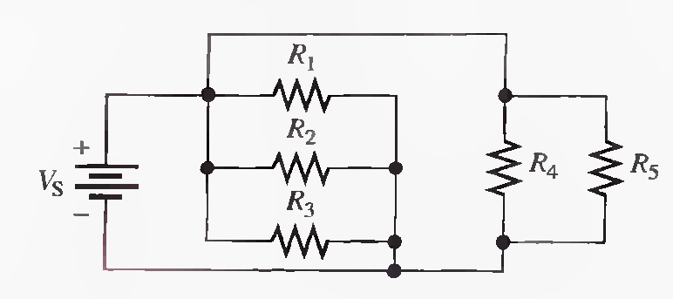

**3. Identify which groups of resistors are in parallel on the double-sided PC board in Figure 6-66.**

Ans: R1, R2 , R5 , R9 , R10, and R12are in parallel.

R4 , R6 , R7 , and R8 are in parallel.

R3 and R11 are in parallel.

# SECTION 6-2 Voltage in a Parallel Circuit

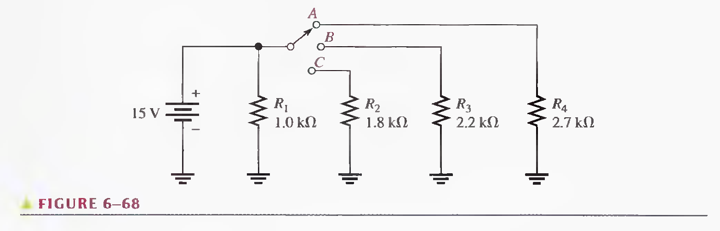

**7. What is the voltage across each resistor in Figure 6-68 for each switch position?**

Ans: Position A:

V1 = 15 V, V2 = 0 V, V3 = 0 V, V4 = 15 V

Position B:

V1 = 15 V, V2 = 0 V, V3 = 15 V, V4 = 0 V

Position C:

V1 = 15 V, V2 = 15 V, V3 = 0 V, V4 = 0 V

**8. What is the total current from the voltage source in Figure 6-68 for each switch position?**

Ans: Position A:

I1 = V1/R1 = 15/1000 = 13 mA

I2 = V2/R2 = 0/1800 = 0 A

I3 = V3/R3 = 0/1000 = 0 A

I4 = V4/R4 = 15/1000 = 13 mA

Position B:

11 = 13 mA, I2 = 0 A, I3 = 13 mA, I4 = 0 A

Position C:

I1 = 13 mA, I2 = 13 mA, I3 = 0 A, I4 = 0 A

# SECTION 6-3 Kirchhoff's Current Law

**13. The total resistance of a parallel circuit is 25 Ω. What is the current through a 220 Ω resistor that makes up part of the parallel circuit if the total current is 100 mA?**

Ans: using current division formula, I = (R/RT) x Is = (25/245) x (.1) = 10.2 mA

# SECTION 6-4 Total Parallel Resistance

**20. If the total resistance in Figure 6-71 is 389.2 Ω, what is the value of R2 ?**

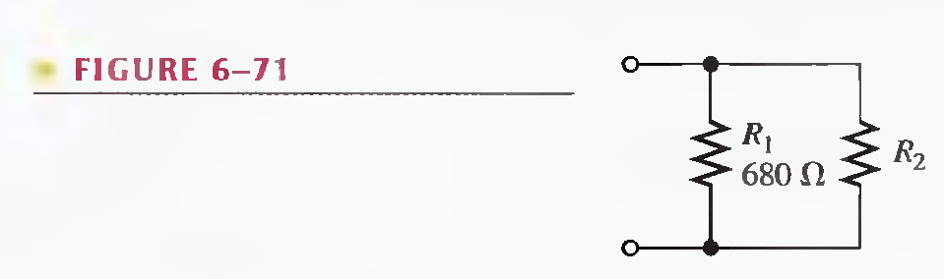

Ans: RT = R1 + R2 🡺 R2 = RT - R1 = 389.2 – 680 = -290.8 Ω

**21. What is the total resistance between point A and ground in Figure 6-72 for the following conditions?**

1. **SWI and SW2 open**
2. **SWI closed. SW2 open**
3. **SWI open, SW2 closed**
4. **SWI and SW2 closed**

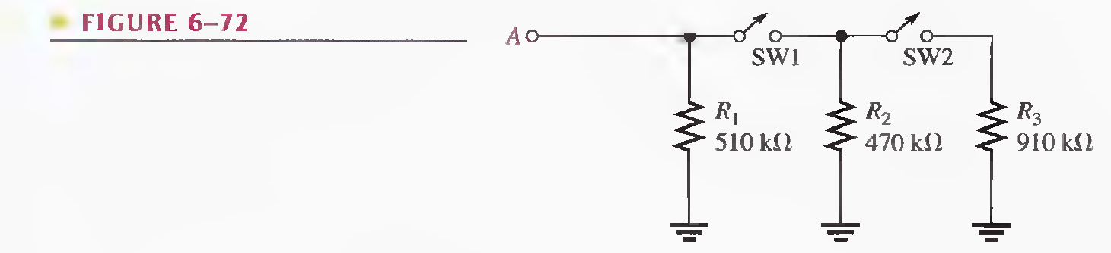

Ans: a) RT = 510 kΩ

1. RT = (1/510) + (1/470) = 245 kΩ
2. RT = 510 kΩ
3. RT = (1/510) + (1/470) + (1/910) = 193 kΩ

# SECTION 6-5 Application of Ohm's Law

**29. Find the values of the unspecified quantities in Figure 6-77.**

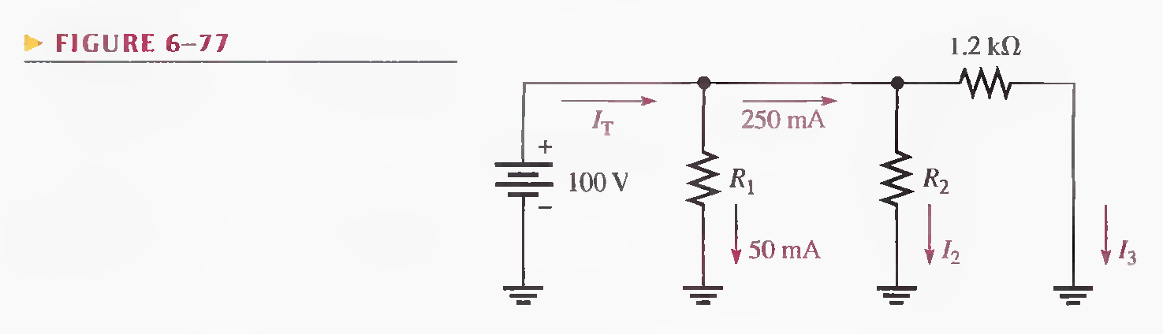

Ans: IT = 50 + 250 = 300 mA

R1 = V/I = 100/0.05 = 2 kΩ

I3 = 100/1200 = 83.3 mA

I2 = 250 – 83.3 = 166.7 mA

R2 = 100/0.1667 = 599.8 Ω

# SECTION 6-6 Current Sources in Parallel

30. Determine the current through RL in each circuit in Figure 6-78.

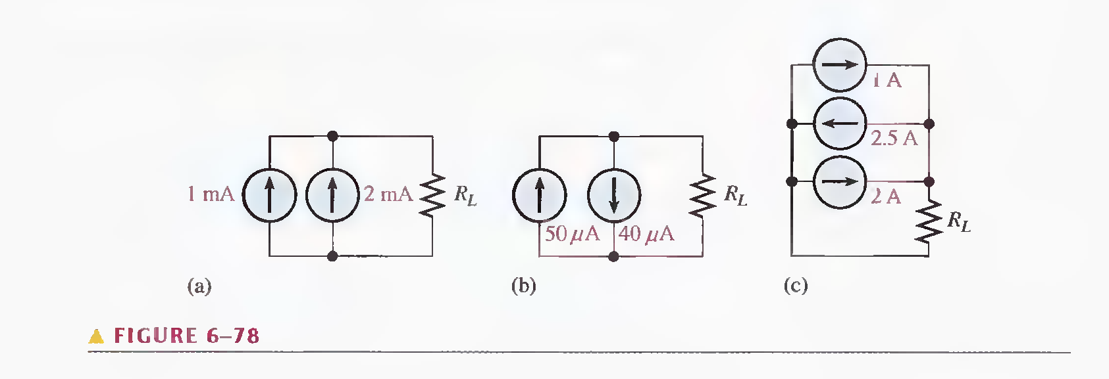

Ans: a) current through RL = 1 + 2 = 3 mA

b) current through RL = 50 - 40 = 10 µA

c) current through RL = 1 – 2.5 + 2 = 0.5 A

**31. Find the current through the resistor for each position of the ganged switch in Figure 6-79.**

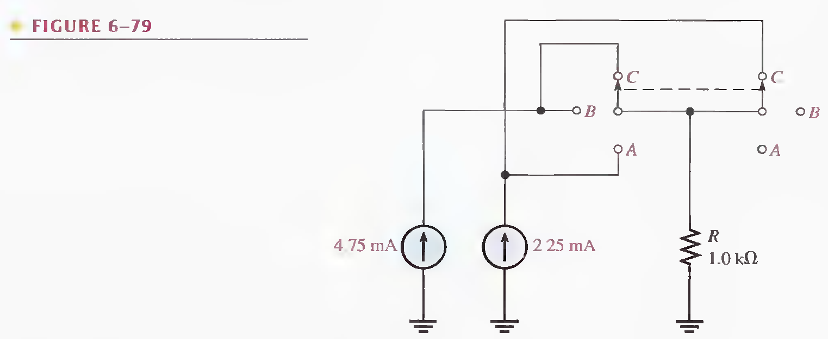

Ans: position C: current through the resistor = 4.75 + 2.25 = 7 mA

position B: current through the resistor = 4.75 mA

position A: current through the resistor = 2.25 mA

# SECTION 6-7 Current Dividers

**35. Determine all of the resistor values in Figure 6-83. RT = 773 Ω.**

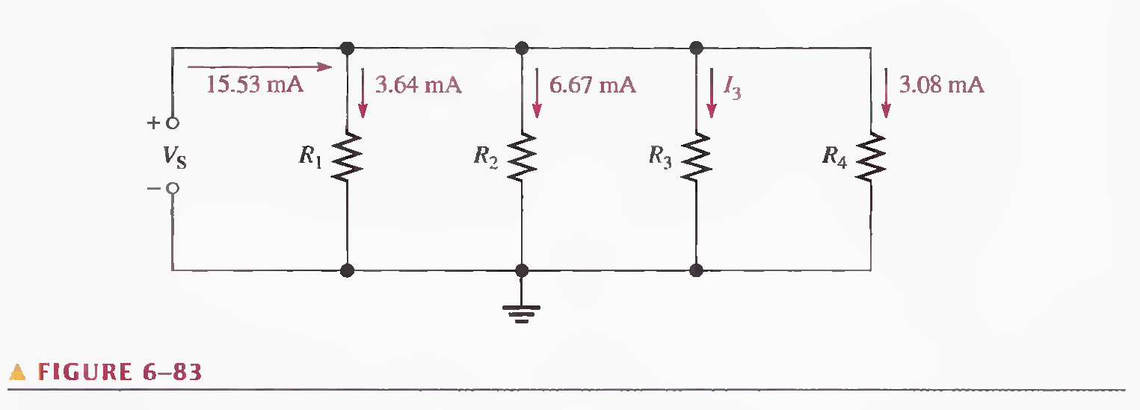

Ans:

# Chapter 7

# SECTIONN 7-1 Identifying Series-Parallel Relationships

**3. In each circuit of Figure 7-62, identify the series and parallel relationships of the resistors viewed from the source.**

Ans: (a) R1 and R4 are in series with the parallel combination of R2andR3.

(b) R1 is in series with the parallel combination of R2, R3, and R4.

(c) The parallel combination of R2 and R3 is in series with the parallel combination of R4 and R5. This is all in parallel with R1.

**5. Draw the schematic of the PC board layout in Figure 7-64 showing resistor values and identify the series-parallel relationships.**

Ans:

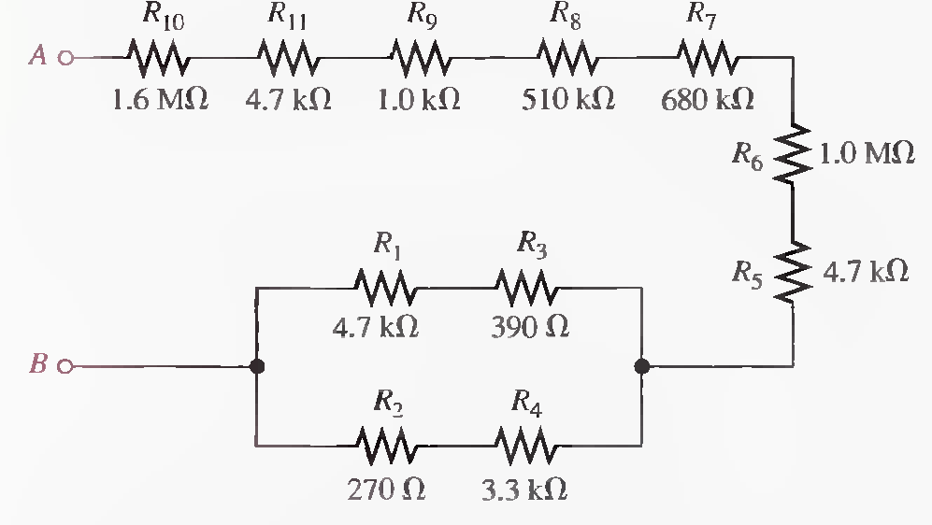

# SECTION 7-2 Analysis of Series-Parallel Resistive Circuits

**23. Find the resistance between each of the following sets of nodes in Figure 7-72: AB, BC, and CD.**

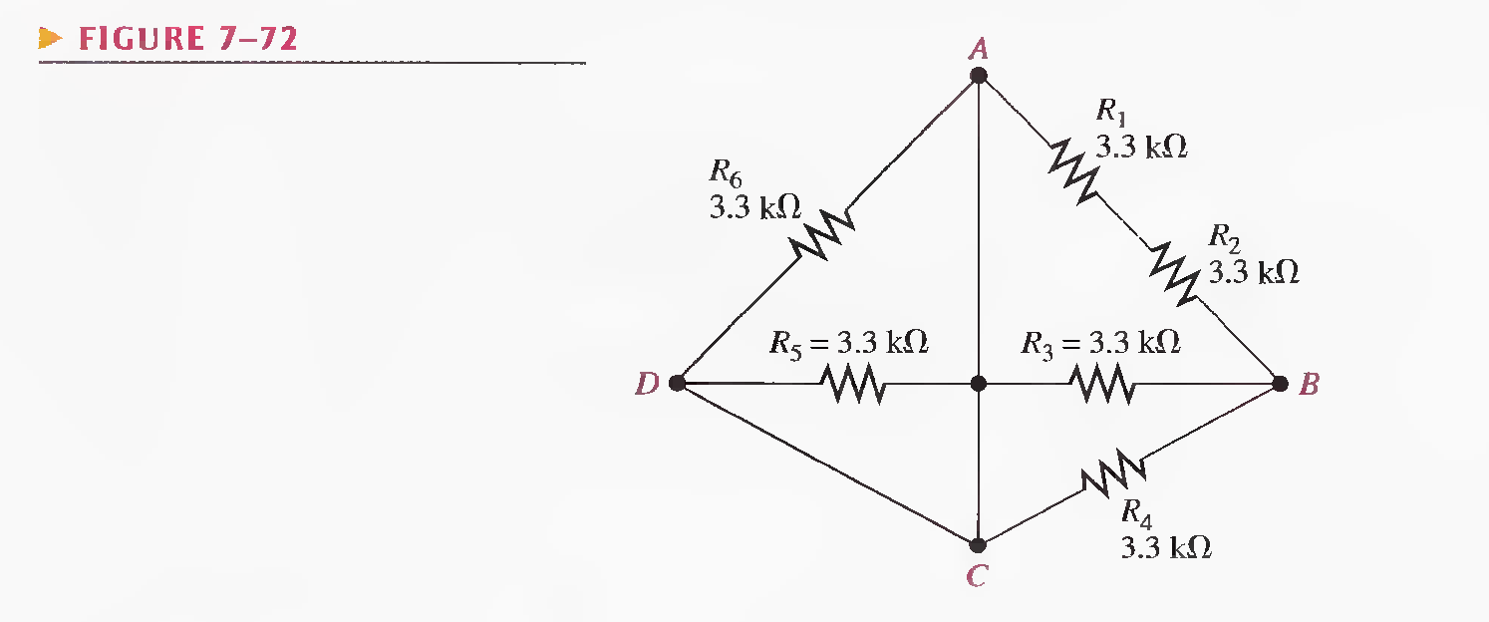

Ans: = 1.32 kΩ

= 1.32 kΩ

Now path from C to D is short circuit so,

R CD = 0 Ω

# SECTION 7-3 Voltage Dividers with Resistive Loads

**25. A voltage divider consists of two 56 kΩ resistors and a 15 V source. Calculate the unloaded output voltage. What will the output voltage be if a load resistor of 1.0 MΩ is connected to the output?**

Ans: unloaded output voltage = 15/2 = 7.5 V

VLoad = 53.03/(0.109030) x 15 = 7.295 V

**34. Design a voltage divider to provide a 6 V output with no load and a minimum of 5.5 V across a 1.0 kΩ load. The source voltage is 24 V, and the unloaded current drain is not to exceed 100 mA.**

Ans:

# SECTION 7-4 Loading Effect of a Voltmeter

**37. The voltmeter described in Problem 36 is used to measure the voltage across R4 in Figure 7-62(a).**

**(a) What range should be used?**

**(b) How much less is the voltage measured by the meter than the actual voltage?**

Ans: (a) range = 0.5 V

(b) current = 1 mV Approx.

# SECTION 7-5 Ladder Networks

**40. Determine the total resistance in the ladder network of Figure 7-78.**

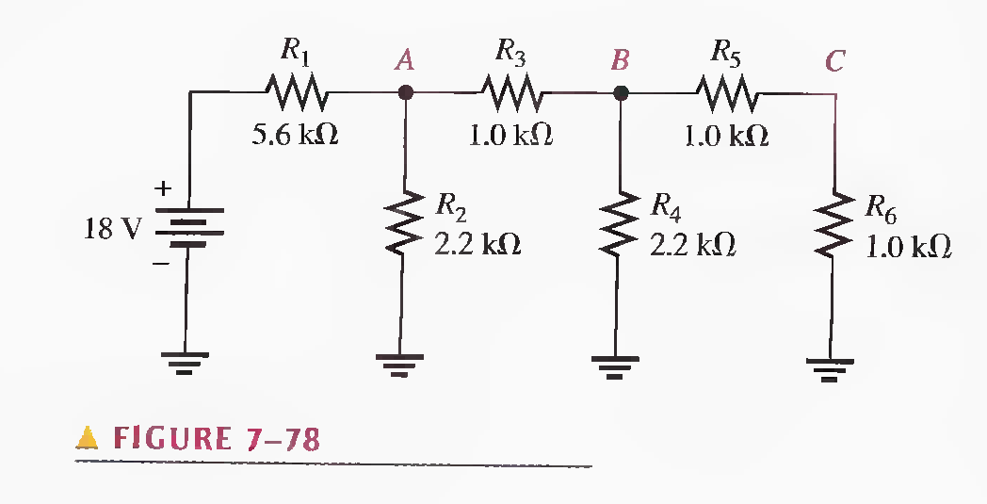

Ans: RT = R1 + (R2||(R3 + (R4||(R5 + R6))) = 6.6605 k Ω

# SECTION 7-6 The Wheatstone Bridge

**46. A resistor of unknown value is connected to a Wheatstone bridge circuit. The bridge parameters for a balanced condition are set as follows: Rv = 18 kΩ and R2/R4 = 0.02. What is Rx ?**

Ans: Rx  = Rv (R2/R4) = 18000 (0.02) = 360 Ω

**47. A load cell has four identical strain gauges with an unstrained resistance of 120.000 Ω for each gauge (a standard value). When a load is added, the gauges in tension increase their resistance by 60 mΩ to 120.060 Ω and the gauges in compression decrease their resistance by 60 mΩ to 119.940 Ω as shown in Figure 7-82. What is the output voltage under load?**

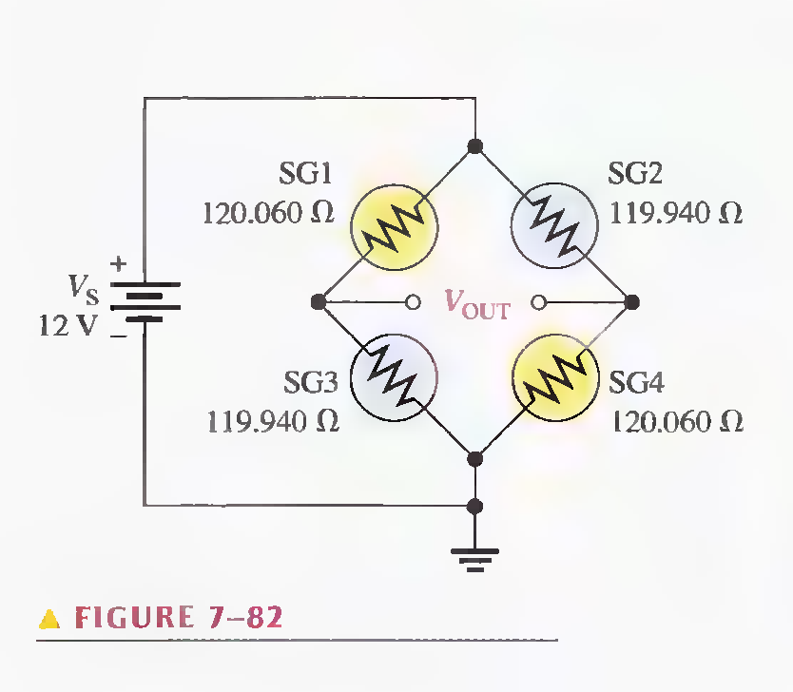

Ans: ∆VOUT = ∆Rtherm (VS/4R)

∆Rtherm  = 120.060 – 119.940 = 0.12 Ω

4R = 120.06 + 119.94 + 119.64 + 120.06 = 479.7000 Ω

now ∆VOUT = (0.12) (12/479.7) = 3.0 mV